**Written Report (15 points)**

To receive all points, the written report presents a cohesive written analysis that:

* Summarises the analysis (5 points)
* Draws two correct conclusions or comparisons from the calculations (10 points)

Summary

To interpret PyCity student data between 15 high schools (grade years 9,10,11 and 12). The education department is well run because 84% passed reading and 86% passed maths of 39170 students, and the overall passing rate was 73%. However, the average scores in maths and reading were about 70. The schools run well, but there are some rooms to improve the study performed in the future. The total school (of 15 schools) budget amount was $24,649,428.

The data analysis represents the table where are the data allocated per school and included the next parameters: schools name, budget per school, capita per student, average reading and maths score, passing score for math and reading, and overall passing score.

The lowest overall passing score belongs to the Hernandez High School (it is about only 66%), this school has 4635 students, a budget of $3,022,020 and student per capita is in the highest range - $652 per student. What means the KPI (key performing indicator) is quite low and should be done some researches how to improve the education and students performance.

The Griffin High School is the leader of the student education performance and passing exam. This school includes 1468 student with the budget of $917,500 and per capita is in the high range - $625.

The top five perform schools includes three independent schools and two government schools with range of capita per student from $582 till $637. The to bottom perform schools includes four government and one independent school with range of capita per student from $578 till $655. This is depression/negative trend for the government schools does not relates with the school budget and does not relate with the financial questions. As we see the above the top five bottom schools have a high number of the student capita. The suggestion will be to check the education quality and research how can be improved the teaching process in government schools.

The analysis of the average mathematics score by the years (9th, 10th, 11th, 12th) demonstrate that there are no big fluctuation about +-0.5% or 1%, and the average trend of the maths score is stable. But the average trend of the reading score in some schools change from the 9th grade to 12th grade. For example, Baily high school the average reading score by 2% better in 12th grade than in grade 9th. However, the Griffin High School has opposite situation.

The table with scores by per capita student spending demonstrate that the lowest passing score (67%) having schools with the highest capita budget - $645-680. Budget $630-645 has 71% avr passing score, budget <$585 has 77% avr passing score and the schools with medium size of the capita budget $585 -630 has the highest passing score 80%. So this is the evidence that the capita budget does not have direct impact on the quality of the teaching/education process and students performance. School with the low passing score, particular governments should review the education process and search how to improve it. However, the average passing score of all schools is high than 65%.

The analysis of the school size shows that small and medium schools have better maths, reading and overall passing scores, than the biggest one, where are students number 2000 and more.

The last table finalise all score by type of the school and we can see that independent schools are leading with average maths and reading scores, and they also are leading with % of the passing score of maths and reading 89%(independent school passing maths) to 84% (government school passing maths) and 86%(independent school passing reading) to 83%(government school passing reading). Overall passing score for the independent schools is 77% that by 6% higher than governments one.

The summary and conclusions above demonstrate that all schools run well the average passing score is higher than 65%. However, the school budget and capita do not have direct impact on the students’ performance. Governments schools have the low-performance rate, it means that study process and the quality of the teaching students should be review and improve. The small and medium size of the schools demonstrate the better results compare to the large one. The gap of the overall passing rate between independent and government schools no more than 6%. And gaps of average maths and reading score no more than 1%. It means that students independents and governments schools demonstrate the same knowledge and skills levels, however some governments schools have to review the education process to be equal or better compare to the independents schools.

* To interpret the Py City School district student data.

## Results

### District Wide Summery

* Analysis of the district data shows overall that the district's ELA departments are well run as 85% of students are passing reading. The math departments in the district might need some reorganization as only 74% of students are passing math.
* [](https://github.com/JasperMagorombo/School_District_Analysis/blob/master/Resources/district_summery_challenge.png)
* Removing the tampered data reduced passing percentages accross the board by 1%, it does not seem that removing the freshman grades from Thomas Highschool had much impact on the district. [](https://github.com/JasperMagorombo/School_District_Analysis/blob/master/Resources/district_summery_module.png)
* With the inclusion of tampered data Thomas High School was one of the top perfroming schools in the district. [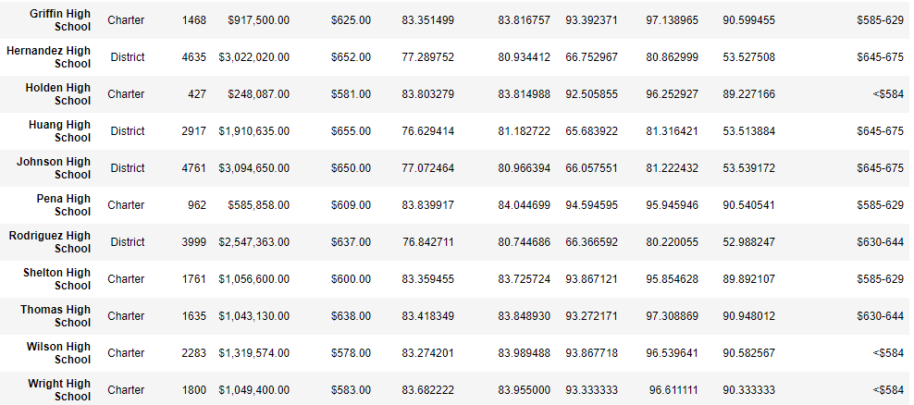](https://github.com/JasperMagorombo/School_District_Analysis/blob/master/Resources/comp_data_module.png)
* Without the freshman data Thomas High's performance plumets. Every performance metric drops and the overvall passing percentage drops by around 25 percentage points from 90% to around 65%.
* [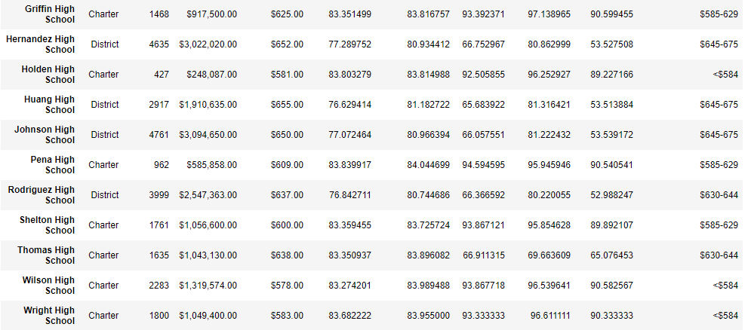](https://github.com/JasperMagorombo/School_District_Analysis/blob/master/Resources/comp_data_challenege.png)

### School Summery

#### Top 5

* The removal of Thomas High freshman data had a promient effect on the district rankings as they were knocked out of the top 5 perfroming schools. [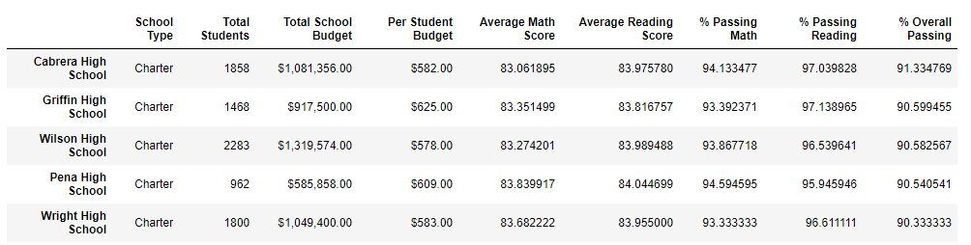](https://github.com/JasperMagorombo/School_District_Analysis/blob/master/Resources/top_5_challenge.png)
* Even with the removal of Thomas five from the top 5, it still remains dominated by Charter Schools. Charter Schools tend to be small to medium sized making them easier to administer, it is likely this is leading their higher performance. [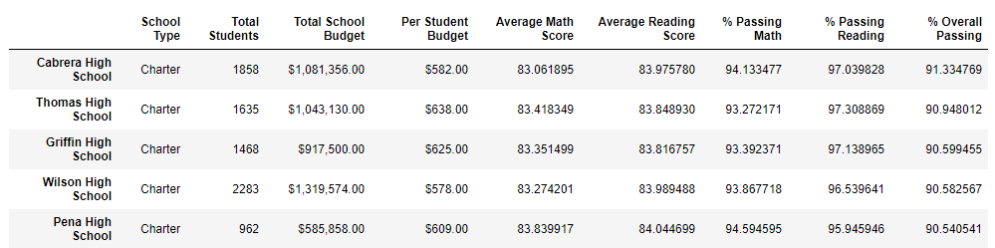](https://github.com/JasperMagorombo/School_District_Analysis/blob/master/Resources/top_5_module.png)

#### Bottom 5

* The bottom 5 schools were not affected with the removal of data. The bottom 5 schools were still all medium to large sized district schools [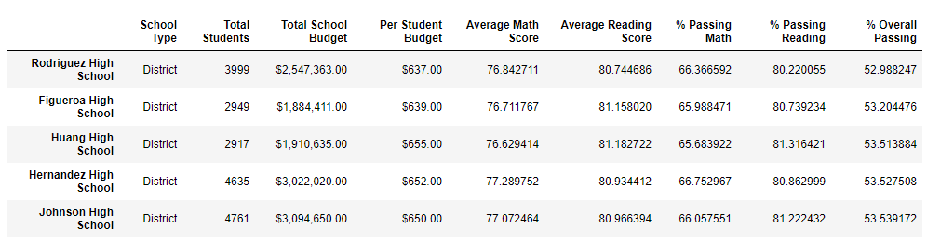](https://github.com/JasperMagorombo/School_District_Analysis/blob/master/Resources/bottom_5_module.png)

#### Scorces by grade

* Average math scores by grade per school.
* [Table

  Description automatically generated](https://github.com/JasperMagorombo/School_District_Analysis/blob/master/Resources/ave_math_challenge.png)
* Average reading scores by grade per school.
* [Table

  Description automatically generated](https://github.com/JasperMagorombo/School_District_Analysis/blob/master/Resources/ave_reading_challenge.png)

## Summery

* The tampering of Thomas High freshman data, while debilitating to Thomas High's metrics, overall did not have a major impact on the school district's metrics. The data overall suggets that smaller to more meduim sized schools have the greatest chance to be successful. If additional resources were to be distributed within the district I would suggest more resources be directed towards the math departments, as they were underperforming compared to the ELA departments.